AI POWERED INTELLIGENT HOSPITAL PATIENT FLOW MANAGEMENT SYSTEM
A PROJECT REPORT
submitted in partial fulfilment of the requirements for the award of the degree of
[BACHELOR OF TECHNOLOGY]
Student | Hall Ticket No.
A. RAMU | 23K91A6715
B. RUSHI | 23K91A6720
B. RAJ KUMAR | 23K91A6725
A. PRABHAS | 23K91A6703
Under the guidance of
[GUIDE NAME]
[DESIGNATION]
Department of Computer Science and Engineering (Data Science)
[COLLEGE NAME]
[CITY]
[ACADEMIC YEAR]

CERTIFICATE

This is to certify that the project report entitled “AI Powered Intelligent Hospital Patient Flow Management System” is a bonafide record of the work carried out by A. RAMU, B. RUSHI, B. RAJ KUMAR, A. PRABHAS under the guidance of [GUIDE NAME], submitted to [COLLEGE NAME] in partial fulfilment of the requirements for the award of [DEGREE] during [ACADEMIC YEAR].
Project Guide: ____________________ Head of Department: ____________________ Principal: ____________________

DECLARATION

We declare that the work presented in this report, entitled “AI Powered Intelligent Hospital Patient Flow Management System,” is our original academic project work. Sources used for background, comparison and implementation have been acknowledged. The reported software measurements were obtained from this project’s artefacts and local execution; no clinical deployment or real patient study is claimed.
Signatures: A. RAMU __________ B. RUSHI __________ B. RAJ KUMAR __________ A. PRABHAS __________

ACKNOWLEDGEMENT

We express our sincere gratitude to our project guide, [GUIDE NAME], [DESIGNATION], for guidance and constructive review. We thank [HOD NAME], Head of the Department, [PRINCIPAL NAME], Principal, and the faculty of [COLLEGE NAME] for the academic environment and facilities used for this work.
We also acknowledge the authors of the Alleviate base paper and the open-source communities behind Python, FastAPI, scikit-learn, SQLAlchemy, React and their supporting libraries.

ABSTRACT

Hospitals coordinate registration, queues, consultation, laboratory work, pharmacy, wards and intensive care through interdependent decisions. When these states are fragmented across calls, registers or isolated screens, staff cannot see one reliable operational picture. CareFlow is a full-stack academic prototype that issues digital tokens, tracks visits, manages laboratory and bed states, publishes live updates and provides role-specific dashboards.
Two machine-learning components assist the workflow. A Random Forest regressor estimates wait time from synthetic queue context, and a Gradient Boosting classifier estimates triage priority from synthetic vital-sign data labelled with a simplified early-warning rule. On deterministic test partitions the wait model achieved R-squared 0.951041, MAE 5.982 minutes and RMSE 8.580 minutes; triage achieved 96.80% accuracy and 0.898475 macro F1, but only 63% critical recall. The results therefore demonstrate software integration and reproducible synthetic evaluation, not clinical validity.

TABLE OF CONTENTS
CHAPTER 1 INTRODUCTION 15
1.1 Domain and Background 15
CHAPTER 1 INTRODUCTION 16
1.2 Motivation and Current Practice 16
CHAPTER 1 INTRODUCTION 17
1.3 Problem Statement and Need 17
CHAPTER 1 INTRODUCTION 18
1.4 Objectives and Contributions 18
CHAPTER 1 INTRODUCTION 19
1.5 Scope, Limitations and Organisation 19
CHAPTER 2 LITERATURE SURVEY 20
2.1 Overview 20
CHAPTER 2 LITERATURE SURVEY 21
2.2 Base Paper Analysis 21
CHAPTER 2 LITERATURE SURVEY 22
2.3 Related Work: Access and Recommendation 22
CHAPTER 2 LITERATURE SURVEY 23
2.4 Related Work: Personalisation and Conversational Support 23
CHAPTER 2 LITERATURE SURVEY 24
2.5 Waiting-Time Research and Comparison 24
CHAPTER 2 LITERATURE SURVEY 25
2.6 Research Gap 25
CHAPTER 3 FEASIBILITY STUDY 26
3.1 Technical and Economic Feasibility 26
CHAPTER 3 FEASIBILITY STUDY 27
3.2 Operational and Schedule Feasibility 27
CHAPTER 3 FEASIBILITY STUDY 28
3.3 Advantages and Constraints 28
CHAPTER 3 FEASIBILITY STUDY 29
3.4 Risk Assessment 29
CHAPTER 4 SYSTEM REQUIREMENTS AND ANALYSIS 30
4.1 Existing and Proposed Systems 30
CHAPTER 4 SYSTEM REQUIREMENTS AND ANALYSIS 31
4.2 Functional Requirements 31
CHAPTER 4 SYSTEM REQUIREMENTS AND ANALYSIS 32
4.3 Non-Functional Requirements 32
CHAPTER 4 SYSTEM REQUIREMENTS AND ANALYSIS 33
4.4 Hardware and Software Requirements 33
CHAPTER 4 SYSTEM REQUIREMENTS AND ANALYSIS 34
4.5 User Roles and Constraints 34
CHAPTER 4 SYSTEM REQUIREMENTS AND ANALYSIS 35
4.6 Requirement Traceability 35
CHAPTER 5 SYSTEM DESIGN 36
5.1 Overall System Architecture 36
CHAPTER 5 SYSTEM DESIGN 37
5.2 High-Level Workflow 37
CHAPTER 5 SYSTEM DESIGN 38
5.3 DFD Level 0 38
CHAPTER 5 SYSTEM DESIGN 39
5.4 DFD Level 1 39
CHAPTER 5 SYSTEM DESIGN 40
5.5 DFD Level 2 40
CHAPTER 5 SYSTEM DESIGN 41
5.6 Use-Case Design 41
CHAPTER 5 SYSTEM DESIGN 42
5.7 UML Class Design 42
CHAPTER 5 SYSTEM DESIGN 43
5.8 Sequence Design 43
CHAPTER 5 SYSTEM DESIGN 44
5.9 Database Design 44
CHAPTER 5 SYSTEM DESIGN 45
5.10 Database Schema 45
CHAPTER 5 SYSTEM DESIGN 46
5.11 Module Design 46
CHAPTER 5 SYSTEM DESIGN 47
5.12 User Interface Design 47
CHAPTER 6 METHODOLOGY AND SOFTWARE IMPLEMENTATION 48
6.1 Overall Methodology 48
CHAPTER 6 METHODOLOGY AND SOFTWARE IMPLEMENTATION 49
6.2 Dataset Source and Split 49
CHAPTER 6 METHODOLOGY AND SOFTWARE IMPLEMENTATION 50
6.3 Preprocessing 50
CHAPTER 6 METHODOLOGY AND SOFTWARE IMPLEMENTATION 51
6.4 Triage Algorithm 51
CHAPTER 6 METHODOLOGY AND SOFTWARE IMPLEMENTATION 52
6.5 Wait-Time Algorithm 52
CHAPTER 6 METHODOLOGY AND SOFTWARE IMPLEMENTATION 53
6.6 Training and Evaluation 53
CHAPTER 6 METHODOLOGY AND SOFTWARE IMPLEMENTATION 54
6.7 Application Implementation 54
CHAPTER 6 METHODOLOGY AND SOFTWARE IMPLEMENTATION 55
6.8 API, Security and Error Handling 55
CHAPTER 6 METHODOLOGY AND SOFTWARE IMPLEMENTATION 56
6.9 Installation and Execution 56
CHAPTER 7 SYSTEM TESTING 57
7.1 Strategy and Limits 57
CHAPTER 7 SYSTEM TESTING 58
7.2 API Smoke Results 58
CHAPTER 7 SYSTEM TESTING 59
7.3 Frontend Static and Build Verification 59
CHAPTER 7 SYSTEM TESTING 60
7.4 Functional and Edge Observations 60
CHAPTER 7 SYSTEM TESTING 61
7.5 Security and Performance Boundaries 61
CHAPTER 7 SYSTEM TESTING 62
7.6 User Acceptance Limit 62
CHAPTER 8 RESULTS AND OUTPUT SCREENS 63
8.1 Public Waiting Board 63
CHAPTER 8 RESULTS AND OUTPUT SCREENS 64
8.2 Administrator Overview 64
CHAPTER 8 RESULTS AND OUTPUT SCREENS 65
8.3 Reception Output 65
CHAPTER 8 RESULTS AND OUTPUT SCREENS 66
8.4 Registration Input 66
CHAPTER 8 RESULTS AND OUTPUT SCREENS 67
8.5 Doctor Queue 67
CHAPTER 8 RESULTS AND OUTPUT SCREENS 68
8.6 Patient Detail 68
CHAPTER 8 RESULTS AND OUTPUT SCREENS 69
8.7 Laboratory Order 69
CHAPTER 8 RESULTS AND OUTPUT SCREENS 70
8.8 Admission Selection 70
CHAPTER 8 RESULTS AND OUTPUT SCREENS 71
8.9 Ward Capacity 71
CHAPTER 8 RESULTS AND OUTPUT SCREENS 72
8.10 ICU Capacity 72
CHAPTER 8 RESULTS AND OUTPUT SCREENS 73
8.11 Laboratory Workflow 73
CHAPTER 8 RESULTS AND OUTPUT SCREENS 74
8.12 Model Results 74
CHAPTER 8 RESULTS AND OUTPUT SCREENS 75
8.13 Confusion and Failure Analysis 75
CHAPTER 8 RESULTS AND OUTPUT SCREENS 76
8.14 API and Capacity Results 76
CHAPTER 8 RESULTS AND OUTPUT SCREENS 77
8.15 Objectives versus Outcomes 77
CHAPTER 9 CONCLUSION 78
9.1 Summary and Objectives Achieved 78
CHAPTER 9 CONCLUSION 79
9.2 Findings, Applications and Limitations 79
CHAPTER 10 FUTURE SCOPE 80
10.1 Improvements and Further Research 80
CHAPTER 10 FUTURE SCOPE 81
10.2 Scalability, Deployment and Integration 81
REFERENCES 82
REFERENCES 83
REFERENCES 84
APPENDIX A: IMPORTANT CODE 85
A.1 Queue ordering 85
APPENDIX A: IMPORTANT CODE 86
A.2 Wait prediction features 86
APPENDIX A: IMPORTANT CODE 87
A.3 Visit creation orchestration 87
APPENDIX A: IMPORTANT CODE 88
A.4 Role enforcement 88
APPENDIX B: INSTALLATION AND USER GUIDE 89
B.1 Local Installation 89
APPENDIX B: INSTALLATION AND USER GUIDE 90
B.2 Start and Sign In 90
APPENDIX B: INSTALLATION AND USER GUIDE 91
B.3 Role Workflows 91
APPENDIX C: ADDITIONAL SCREENS 92
C.1 Staff Sign-In 92
APPENDIX C: ADDITIONAL SCREENS 93
C.2 Registration Detail 93
APPENDIX C: ADDITIONAL SCREENS 94
C.3 Patient Detail 94
APPENDIX C: ADDITIONAL SCREENS 95
C.4 Admission Detail 95

LIST OF FIGURES
Figure 1. System architecture
Figure 2. High-level workflow
Figure 3. DFD Level 0
Figure 4. DFD Level 1
Figure 5. DFD Level 2
Figure 6. Use-case diagram
Figure 7. UML class diagram
Figure 8. Registration sequence
Figure 9. Entity-relationship diagram
Figure 10. Core algorithm flowchart
Figure 11. Triage confusion matrix
Figure 12. Measured model metrics
Figure 13. API latency
Figure 14. Public waiting board
Figure 15. Administrator dashboard
Figure 16. Reception dashboard
Figure 17. Doctor dashboard
Figure 18. Ward and ICU boards
Figure 19. Laboratory dashboard

LIST OF TABLES
Table 1. Literature comparison
Table 2. Feasibility summary
Table 3. Functional requirements
Table 4. Non-functional requirements
Table 5. User roles
Table 6. Database entities
Table 7. API groups
Table 8. Model results
Table 9. Smoke-test results
Table 10. Objectives versus outcomes
Table 11. Future scope

LIST OF ABBREVIATIONS
Abbreviation | Meaning
AI | Artificial Intelligence
API | Application Programming Interface
DFD | Data Flow Diagram
EHR | Electronic Health Record
ER | Entity Relationship
FHIR | Fast Healthcare Interoperability Resources
ICU | Intensive Care Unit
JWT | JSON Web Token
MAE | Mean Absolute Error
NEWS2 | National Early Warning Score 2
OPD | Outpatient Department
REST | Representational State Transfer
RMSE | Root Mean Squared Error
UML | Unified Modeling Language

CHAPTER 1 INTRODUCTION

1.1 Domain and Background
Patient flow is the sequence of clinical and operational states through which a person moves after arriving at a hospital. Registration, queueing, consultation, tests, pharmacy, ward and intensive-care resources are coupled: a delay or stale state in one department propagates to others.
CareFlow treats that sequence as shared operational data. Its aim is not to diagnose disease but to make queues, resource state and inter-department transitions visible to the authorised people responsible for them.

CHAPTER 1 INTRODUCTION

1.2 Motivation and Current Practice
The supplied project brief identifies manual name calling, telephone bed checks and hand-managed laboratory queues as sources of uncertainty. Conventional hospital management software may digitise billing and registration without coordinating the internal journey in real time.
A useful prototype therefore needs one visit identity, a visible token, explicit status values, department ownership and live resource views. Prediction can support communication only when its evidence and limitations are shown honestly.

CHAPTER 1 INTRODUCTION

1.3 Problem Statement and Need
The problem is to coordinate a patient’s in-hospital flow across OPD, laboratory, pharmacy, ward, ICU and emergency services while preserving priority and current state. Staff need to know who is waiting, what action is pending and whether a resource is available. Patients need a clear token and expected wait.
The need is operational: reduce information fragmentation, not to claim a measured clinical outcome. This report distinguishes implemented functionality, synthetic-model performance and unmeasured impact.

CHAPTER 1 INTRODUCTION

1.4 Objectives and Contributions
Table 1.1 Objectives.
Objective | Implemented evidence
Tokens | Department code plus daily sequence
Movement | MovementLog on registration/explicit transfer
Labs | Order and status routes
Beds | Availability, admit and release routes
AI assistance | Triage and wait predictors
Dashboards | Five roles plus public board
The objectives are to issue digital tokens, track visit movement, coordinate laboratory tasks, expose bed/ICU availability, assist priority and wait estimation, and provide role dashboards. The contributions are a unified Visit state, priority-aware queue ordering, two reproducible model artefacts, resource workflows, WebSocket refresh and a documented evidence boundary.

CHAPTER 1 INTRODUCTION

1.5 Scope, Limitations and Organisation
Scope ends at an academic local prototype. Billing, real EHR integration, diagnosis, production identity, notification providers, cloud scaling and clinical decision authority are excluded. Synthetic data, 63% critical recall, missing automated tests and production-security gaps are material limitations.
Chapters 2–4 review prior work, feasibility and requirements; Chapters 5–6 describe design and implementation; Chapters 7–8 report testing and results; Chapters 9–10 conclude and identify future work. References and three appendices follow.

CHAPTER 2 LITERATURE SURVEY

2.1 Overview
Related work spans patient-facing healthcare applications, disease or specialist recommendation, location services, personalised diet/exercise planning and waiting-time prediction. These streams show the value of integrated access but often stop before in-hospital resource coordination.
The survey uses the supplied Alleviate paper as the base paper and the sources already cited in the batch literature document. Reported figures remain attributed to their original tasks.

CHAPTER 2 LITERATURE SURVEY

2.2 Base Paper Analysis
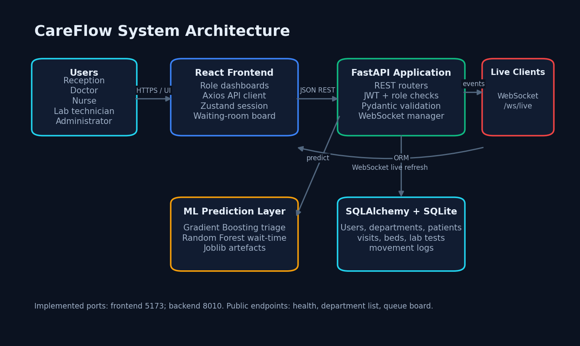
Figure 2.1 CareFlow architecture used for contrast with the base paper.
Alleviate combines Flutter/Dart, Flask and Firebase with specialist recommendation, prescription management, clinic dashboards, maps, appointments, diet/exercise planning and doctor verification. It reports 97.24% precision for its logistic-regression recommendation task and 84.76% precision for a diet-plan Random Forest.
Its focus is patient-side access and personalisation. CareFlow adopts the integrated dashboard principle but changes the problem to internal queues, visit state, laboratory work and bed capacity. The model tasks and datasets differ, so numerical comparison would be invalid.

CHAPTER 2 LITERATURE SURVEY

2.3 Related Work: Access and Recommendation
Tan et al. integrate symptom diagnosis, health records and hospital recommendation; Abinaya and Ganesan, Munir et al., and Nimbalkar and Fadnavis focus on locating appropriate or nearby facilities. Kumar, Gujar et al., and Bhanuteja et al. apply classification to disease or doctor recommendation.
These systems show that structured inputs and role-aware services can improve access. They do not by themselves represent the changing operational state of a patient already moving through a hospital.

CHAPTER 2 LITERATURE SURVEY

2.4 Related Work: Personalisation and Conversational Support
Mogaveera et al. and Tseng et al. combine monitoring with diet and exercise guidance. Tanwar et al., Surve et al., Mendapara et al. and Rahman et al. investigate chatbots, NLP and conversational symptom capture. Umbare et al. combine prediction and location features.
CareFlow deliberately excludes general diagnosis and chatbot advice. Its human-computer interaction is role-specific workflow: a small set of auditable actions backed by explicit database state.

CHAPTER 2 LITERATURE SURVEY

2.5 Waiting-Time Research and Comparison
Table 2.1 Comparison boundary.
Work/theme | Approach | Data | Reported result | Limitation for CareFlow
Alleviate | LR/RF integrated app | Paper-specific datasets | 97.24% recommendation precision | Different task and dataset
Waiting-time studies | ML regression | Observed outpatient context | Source-specific | No shared local dataset
CareFlow | RF wait + GB triage | Synthetic generators | R2 0.951; accuracy 0.968 | No clinical validation
The supplied survey identifies recent work on queue waiting-time prediction, outpatient waiting time and dissatisfaction-aware interpretable prediction. These studies motivate predictive communication but differ in institution, features and outcome definition.
CareFlow’s regressor is trained on a designed queue generator rather than observed hospital arrivals. Its R-squared and error values demonstrate consistency with that generator only.

CHAPTER 2 LITERATURE SURVEY

2.6 Research Gap
The gap is a compact system that connects priority-aware tokens, department ownership, movement evidence, laboratory tasks, ward/ICU capacity and live staff views while making the evidence boundary explicit. CareFlow addresses that application gap.
The project does not claim novelty in NEWS2, Random Forests or Gradient Boosting. Its novelty is integrative and operational. Future research must replace synthetic generators with governed real data and evaluate impact prospectively.

CHAPTER 3 FEASIBILITY STUDY

3.1 Technical and Economic Feasibility
Table 3.1 Feasibility summary.
Dimension | Finding
Hardware | Intel i5-12500 and 15.7 GB RAM sufficient
Software | Open-source local stack
Data | Synthetic generators available; real data absent
Cost | Low prototype cost; production cost unmeasured
The prototype uses mature open-source libraries already available on a standard Windows workstation. FastAPI, SQLAlchemy, scikit-learn, React and SQLite reduce development cost. The saved model artefacts and local database fit comfortably within 15.7 GB RAM.
No paid cloud, messaging or data licence was required. This supports academic feasibility but does not estimate production hosting, support, compliance, integration or clinical-governance cost.

CHAPTER 3 FEASIBILITY STUDY

3.2 Operational and Schedule Feasibility
Each role sees a focused dashboard consistent with its work: registration, consultation, laboratory, bed management or oversight. Seeded demonstration records make the workflow visible without real patient data.
Operational adoption would still require workflow mapping, staff training, downtime procedures, ownership of state updates and governance. The checked-in repository contains no schedule baseline; therefore schedule feasibility is qualitative rather than a measured variance claim.

CHAPTER 3 FEASIBILITY STUDY

3.3 Advantages and Constraints
Advantages include one visit state, explicit queue ordering, traceable movement, visible capacity, reusable APIs and live refresh. Constraints include single-node persistence, development credentials, synthetic evidence, incomplete transition coupling and no production integration.
The system remains feasible as an academic proof of implementation. Its constraints are severe enough that deployment without a redesign would be irresponsible.

CHAPTER 3 FEASIBILITY STUDY

3.4 Risk Assessment
Primary risks are clinical misclassification, stale state, unauthorised access, privacy exposure, service interruption and misleading interpretation of synthetic metrics. Mitigations include clinician override, validation warnings, authenticated channels, audit trails, monitoring, backups and explicit evidence labels.
The current build implements only part of these mitigations. Risk reduction is a future engineering requirement, not a completed outcome.

CHAPTER 4 SYSTEM REQUIREMENTS AND ANALYSIS

4.1 Existing and Proposed Systems
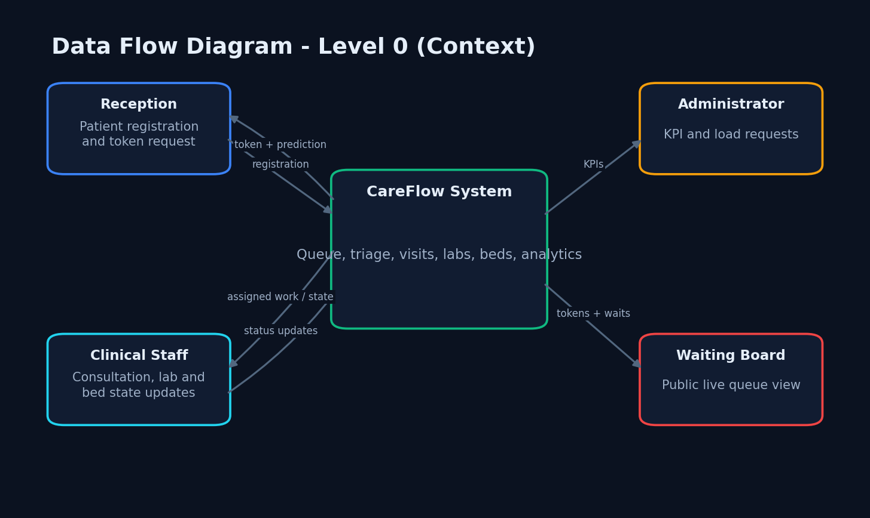
Figure 4.1 System context.
The existing condition described in the project brief uses manual or fragmented coordination. CareFlow proposes a shared visit record, digital token, prediction assistance, laboratory and bed modules, role dashboards and public queue display.
The proposed advantages are visibility and consistency. They were demonstrated through populated screens and API smoke tests; no real hospital comparison was conducted.

CHAPTER 4 SYSTEM REQUIREMENTS AND ANALYSIS

4.2 Functional Requirements
Table 4.1 Functional requirements.
ID | Requirement | Implementation
FR1 | Authenticate staff | JWT login and role checks
FR2 | Register visit | POST /api/visits
FR3 | Issue token | Department code and sequence
FR4 | Prioritise queue | Classifier plus priority sort
FR5 | Manage laboratory work | Lab endpoints and board
FR6 | Manage bed state | Bed endpoints and nurse board
FR7 | Track movement | MovementLog
FR8 | Report live state | KPIs, queue board, WebSocket

CHAPTER 4 SYSTEM REQUIREMENTS AND ANALYSIS

4.3 Non-Functional Requirements
Table 4.2 Non-functional requirements.
Category | Requirement | Current evidence / gap
Performance | Responsive local reads | Mean 3.985–14.231 ms; no load test
Security | Authenticated staff writes | JWT and role checks; WebSocket public
Reliability | Consistent persisted state | SQLite transaction; no failover
Usability | Role-focused screens | Real captures; no UAT
Maintainability | Modular code | Routes/services/models separated
Portability | Documented local run | Windows verified only

CHAPTER 4 SYSTEM REQUIREMENTS AND ANALYSIS

4.4 Hardware and Software Requirements
Measured hardware was a 12th Gen Intel Core i5-12500 with 6 cores, 12 logical processors and 15.7 GB RAM. The development environment used Windows 11 Pro, Python 3.11.9, Node/Vite, Google Chrome and the local filesystem.
Backend packages include FastAPI 0.115.0, SQLAlchemy 2.0.35 and scikit-learn 1.5.2. Frontend packages include React 19, TypeScript, Vite, Axios, Zustand, Recharts and Tailwind CSS.

CHAPTER 4 SYSTEM REQUIREMENTS AND ANALYSIS

4.5 User Roles and Constraints
Table 4.3 User roles.
Role | Principal permissions
Reception | Register and view visits
Doctor | Queue, consultation, lab order, admission, discharge
Nurse | Visit state and bed management
Lab technician | Progress laboratory tests
Administrator | Hospital-wide read/write access
Public viewer | Queue board only

CHAPTER 4 SYSTEM REQUIREMENTS AND ANALYSIS

4.6 Requirement Traceability
Every implemented objective maps to routes, database entities and one or more output screens. The movement objective is partial because not every implicit transition creates a movement record. Laboratory scheduling is a status workflow, not an optimisation algorithm. Waiting-time reduction is not measured.
This traceability prevents a feature shown in marketing copy from being reported as an achieved research result.

CHAPTER 5 SYSTEM DESIGN

5.1 Overall System Architecture
Figure 5.1 System architecture
The client, API, prediction layer, persistence and live channel form five replaceable concerns.

CHAPTER 5 SYSTEM DESIGN

5.2 High-Level Workflow
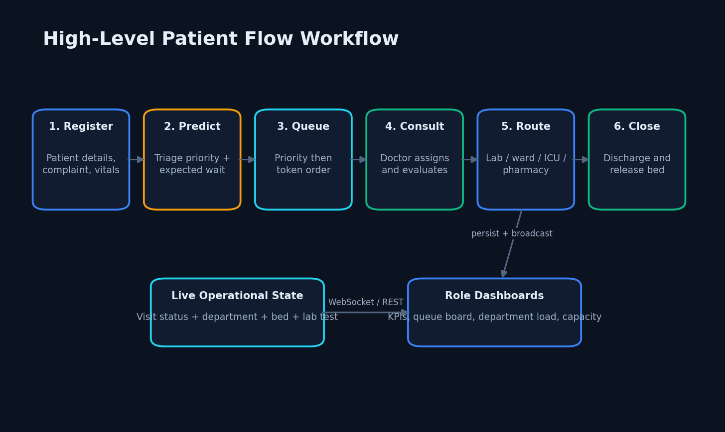
Figure 5.2 High-level workflow
Registration creates a predicted and prioritised visit that staff route to completion.

CHAPTER 5 SYSTEM DESIGN

5.3 DFD Level 0
Figure 5.3 DFD Level 0
External actors exchange bounded operational data with the system.

CHAPTER 5 SYSTEM DESIGN

5.4 DFD Level 1
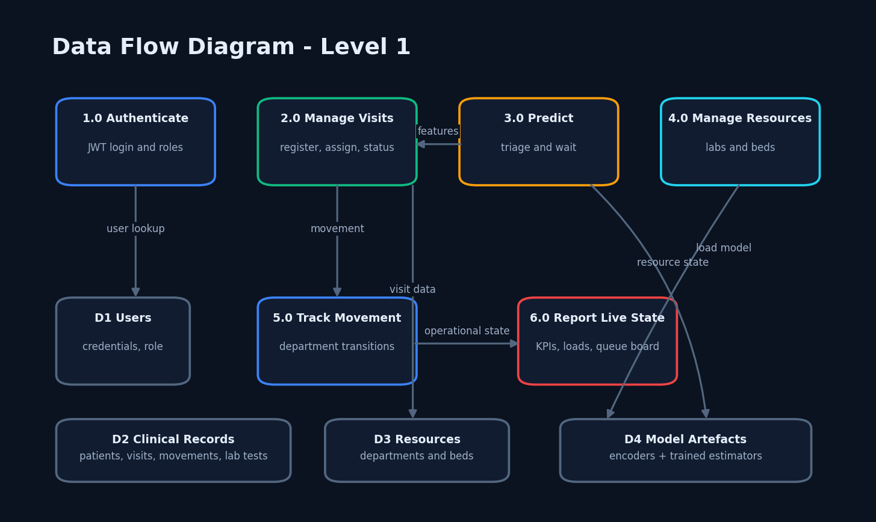
Figure 5.4 DFD Level 1
Authentication, visit, prediction, resource, movement and reporting processes use four data stores.

CHAPTER 5 SYSTEM DESIGN

5.5 DFD Level 2
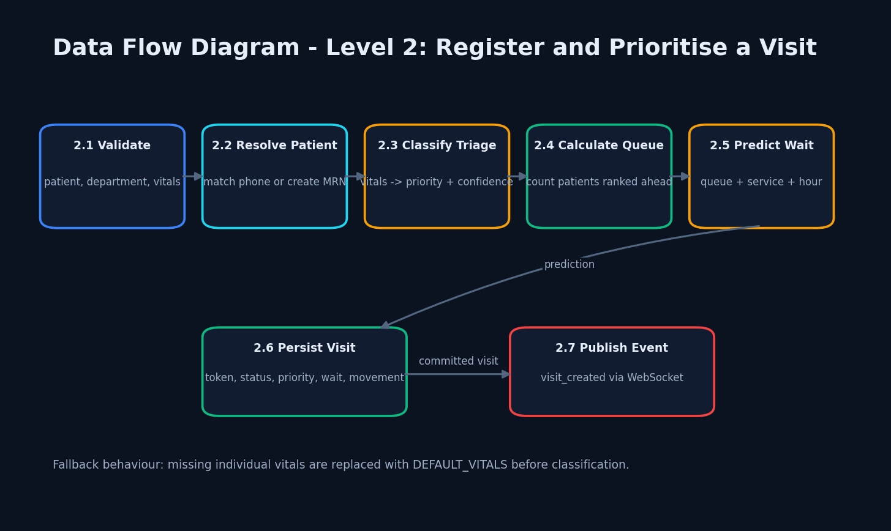
Figure 5.5 DFD Level 2
The visit-creation process is decomposed into validation, identity, inference, queue calculation, persistence and publishing.

CHAPTER 5 SYSTEM DESIGN

5.6 Use-Case Design
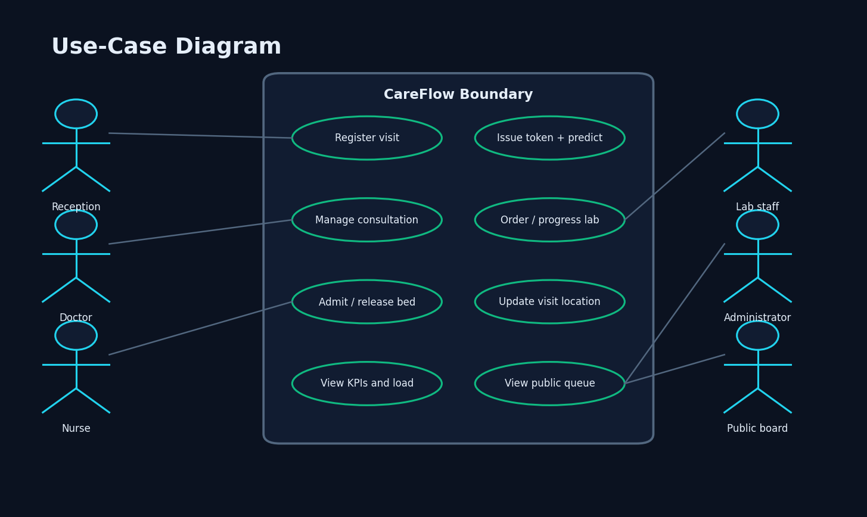
Figure 5.6 Use-case diagram
Use cases reflect the implemented role permissions and public board.

CHAPTER 5 SYSTEM DESIGN

5.7 UML Class Design
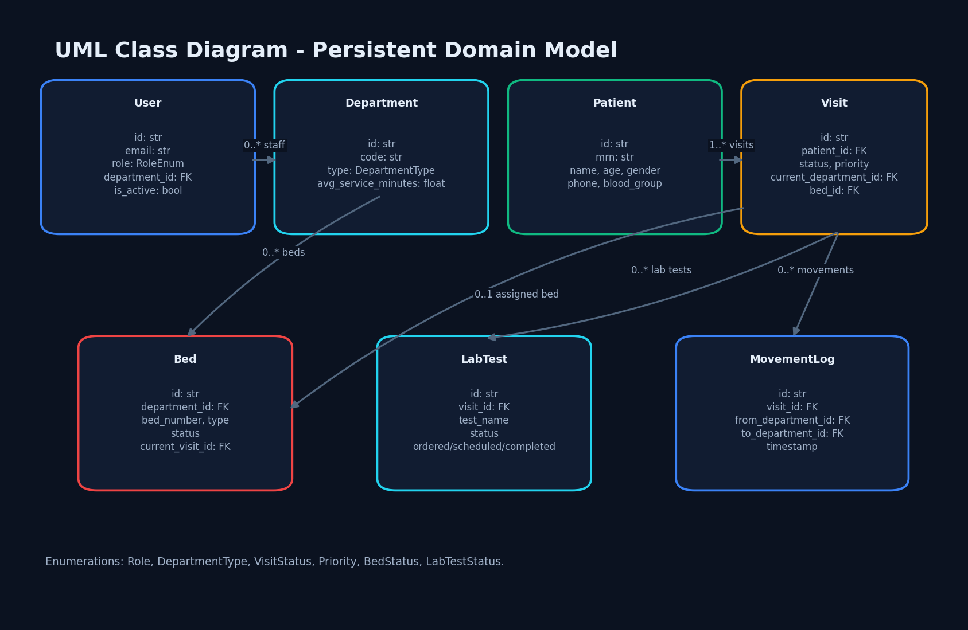
Figure 5.7 UML class diagram
Persistent domain classes and their relationships are shown without invented services.

CHAPTER 5 SYSTEM DESIGN

5.8 Sequence Design
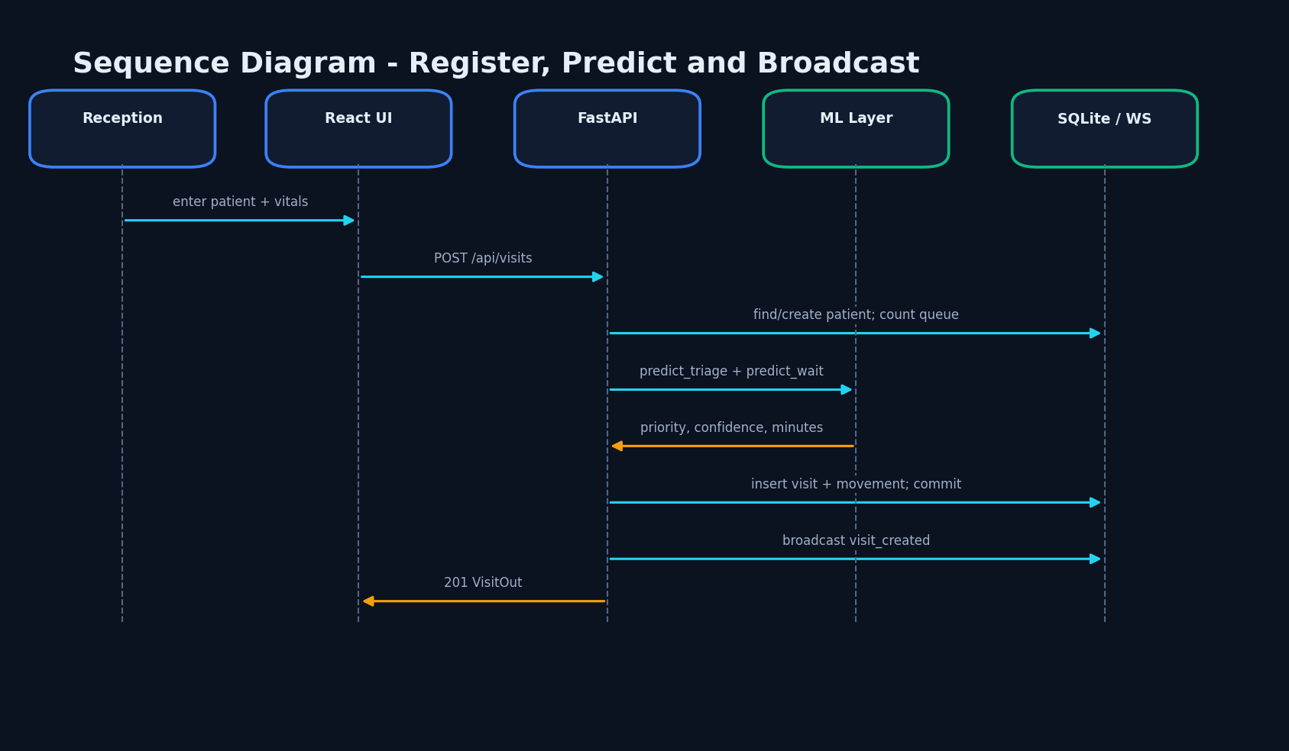
Figure 5.8 Registration sequence
A visit request crosses the UI, API, model, database and live-update channel.

CHAPTER 5 SYSTEM DESIGN

5.9 Database Design
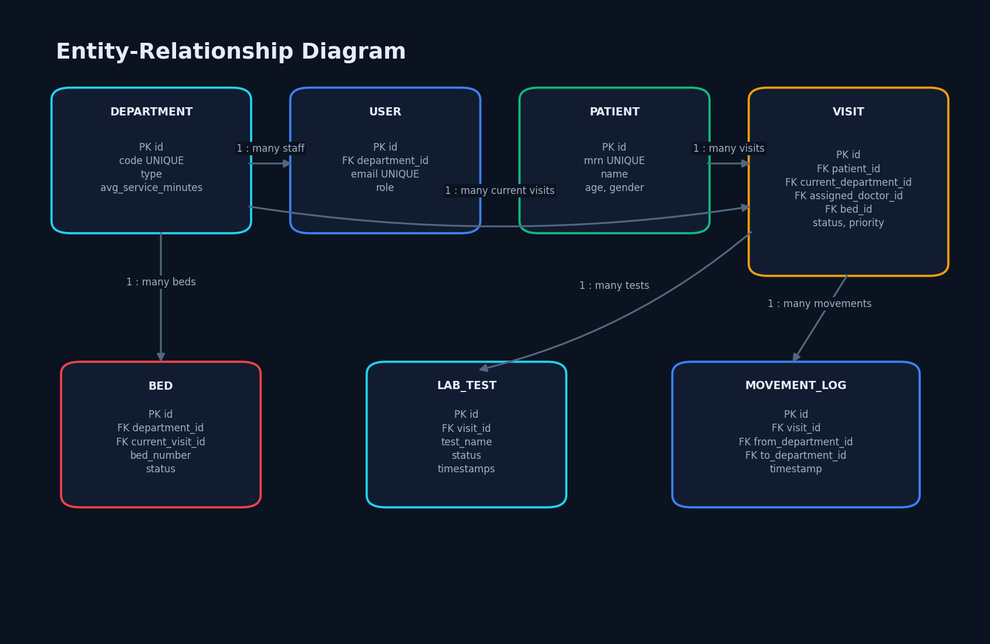
Figure 5.9 Entity-relationship diagram
Foreign keys connect the seven persistent entities.

CHAPTER 5 SYSTEM DESIGN

5.10 Database Schema
Table 5.1 Schema relationships.
Entity | Key relationships
User | department_id -> Department
Visit | patient, department, doctor, bed
Bed | department and optional current visit
LabTest | visit_id -> Visit
MovementLog | visit and from/to departments
Identifiers are 12-character hexadecimal strings. User email, department code and patient MRN are unique. Visits reference patients, departments, optional doctors and beds. Tests and movements are visit children. JSON stores vitals.

CHAPTER 5 SYSTEM DESIGN

5.11 Module Design
Backend modules separate configuration, database, security, models, schemas, route groups, queue rules, WebSocket handling and ML prediction. Frontend modules separate layout, common controls, API functions, session/toast stores, live-socket handling and role pages.
The central coupling remains Visit, which intentionally carries the state shared across modules.

CHAPTER 5 SYSTEM DESIGN

5.12 User Interface Design
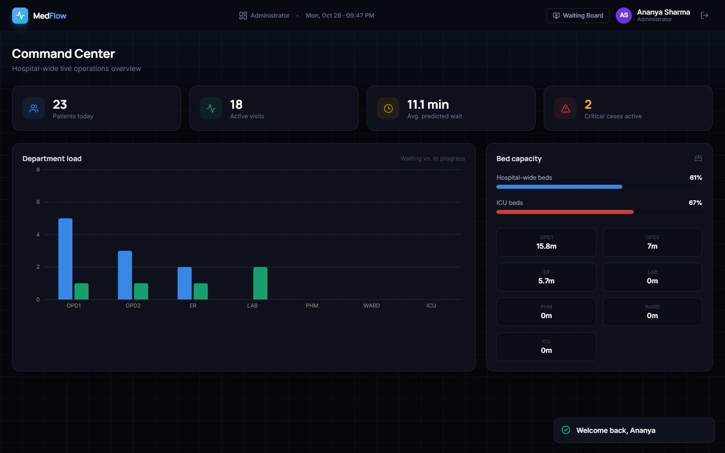
Figure 5.10 Administrator interface example.
The interface uses a dark operational palette, cards, status badges, compact tables and workflow modals. Admin screens favour aggregate visibility; clinical screens favour actionable lists; the public board uses large tokens for distance viewing.
The captured nurse screen also exposed a real initial-tab defect, demonstrating why visual verification is necessary in addition to code review.

CHAPTER 6 METHODOLOGY AND SOFTWARE IMPLEMENTATION

6.1 Overall Methodology
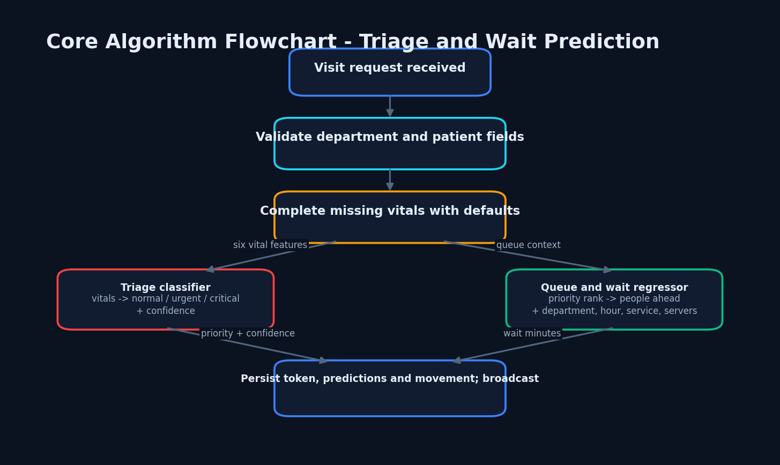
Figure 6.1 Core algorithm flow.
The method comprised fact extraction, code inspection, deterministic model evaluation, additive demonstration data, running-system capture and evidence-controlled documentation. The software pipeline performs validation, prediction, queue allocation, persistence and live publication.

CHAPTER 6 METHODOLOGY AND SOFTWARE IMPLEMENTATION

6.2 Dataset Source and Split
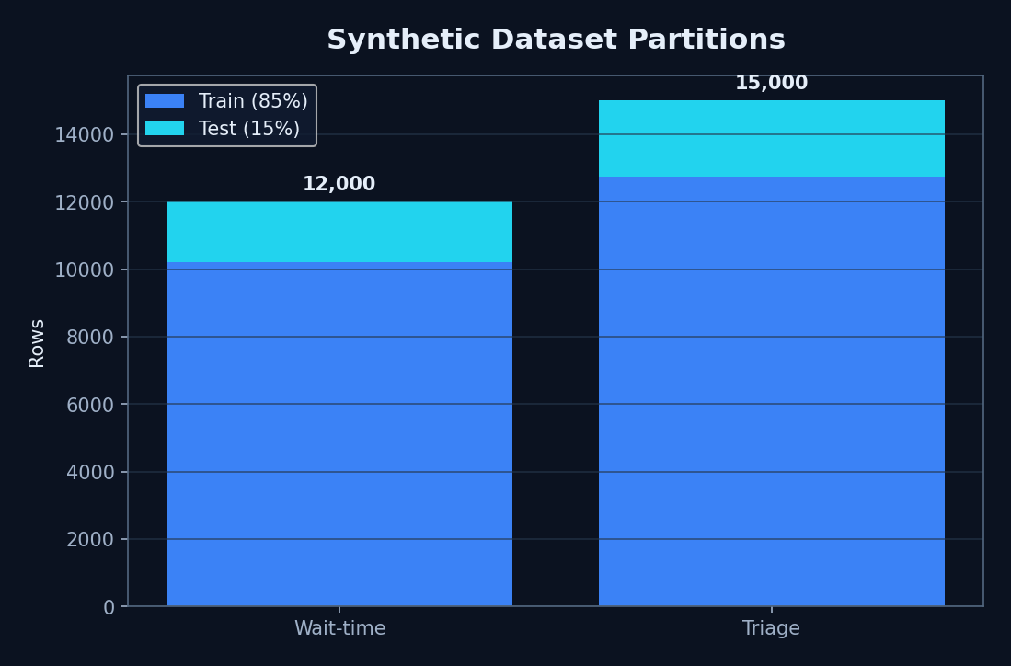
Figure 6.2 Dataset partitions.
Both datasets are generated in train.py with NumPy RNG seed 42. Wait data contains 12,000 rows and triage data 15,000 rows. Each is split 85/15, giving 10,200/1,800 wait rows and 12,750/2,250 triage rows.
No external licence applies to generated records and no real patient information is used.

CHAPTER 6 METHODOLOGY AND SOFTWARE IMPLEMENTATION

6.3 Preprocessing
Department type and priority are encoded with stored LabelEncoder instances. Tree models consume numeric values directly. The inference path preserves training feature names in pandas DataFrames. Missing vital components are filled from DEFAULT_VITALS: heart rate 78, systolic 118, diastolic 76, SpO2 97, temperature 36.9 and respiratory rate 16.
The silent defaulting is convenient for a demonstration but should become an explicit uncertainty state in a clinical redesign.

CHAPTER 6 METHODOLOGY AND SOFTWARE IMPLEMENTATION

6.4 Triage Algorithm
A simplified early-warning function assigns points for extreme respiratory rate, oxygen saturation, temperature, systolic pressure, heart rate and age. Total scores 0–3 are normal, 4–6 urgent and 7 or above critical. A 150-estimator Gradient Boosting classifier learns these labels.
The function is described as NEWS2-style rather than an exact clinical NEWS2 implementation. The saved classifier returns class probability as confidence.

CHAPTER 6 METHODOLOGY AND SOFTWARE IMPLEMENTATION

6.5 Wait-Time Algorithm
Synthetic target wait is based on queue ahead divided by servers, multiplied by average service duration, a 1.35 rush factor during defined hours, a priority factor and Gaussian noise. Results are clipped to 0–240 minutes. The Random Forest uses 200 trees and maximum depth 10.
Runtime inference defaults to two servers and current UTC hour. Department average service time is stored in the database.

CHAPTER 6 METHODOLOGY AND SOFTWARE IMPLEMENTATION

6.6 Training and Evaluation
The test partitions are deterministic and the existing Joblib models were measured without retraining. Wait R-squared was 0.951041, MAE 5.982 minutes and RMSE 8.580 minutes. Triage accuracy was 0.9680, macro precision 0.962435, macro recall 0.858574 and macro F1 0.898475.
These figures are reproducibility evidence within the generator, not clinical generalisation.

CHAPTER 6 METHODOLOGY AND SOFTWARE IMPLEMENTATION

6.7 Application Implementation
FastAPI creates database tables on import and verifies model artefacts at startup. Route functions use SQLAlchemy sessions through dependency injection. Pydantic models validate request ranges and response shape. React pages call a shared Axios client and refresh on selected WebSocket events.
The seed script is destructive by design, but documentation data was inserted additively because existing content had to be preserved.

CHAPTER 6 METHODOLOGY AND SOFTWARE IMPLEMENTATION

6.8 API, Security and Error Handling
JWT authentication, bcrypt passwords and route-level role checks provide the implemented security boundary. CORS accepts configured origins and a localhost regular expression for development. HTTP exceptions represent invalid credentials, permissions, missing records and unavailable beds.
Production controls—TLS termination, secret rotation, authenticated WebSockets, privacy logging, rate limits and least-privilege database accounts—are not implemented.

CHAPTER 6 METHODOLOGY AND SOFTWARE IMPLEMENTATION

6.9 Installation and Execution
Create or activate the backend virtual environment, install requirements, ensure data exist, then run `python -m uvicorn app.main:app --port 8010`. In frontend, run `npm install` and `npm run dev`; Vite serves port 5173 and proxies API and WebSocket requests to 8010.
The repository has no run.bat. Detailed user steps are in Appendix B.

CHAPTER 7 SYSTEM TESTING

7.1 Strategy and Limits
The repository contains no automated unit or integration tests. Verification therefore combined deterministic model evaluation, frontend lint/build, API smoke/latency requests, WebSocket connection and real-browser workflow capture.
This strategy verifies availability and presentation but cannot substitute for automated regression, concurrency, penetration, clinical or user-acceptance testing.

CHAPTER 7 SYSTEM TESTING

7.2 API Smoke Results
Table 7.1 Smoke results.
Evidence | Result
Login | HTTP 200
Read requests | 150/150 HTTP 200
Mean endpoint range | 3.985–14.231 ms
WebSocket connect | 46.657 ms
Login returned HTTP 200. Ten read endpoints received 15 sequential requests each, for 150 successful HTTP 200 responses. The WebSocket connection also succeeded.

CHAPTER 7 SYSTEM TESTING

7.3 Frontend Static and Build Verification
Oxlint exited zero with 14 warnings concerning ref access, state updates in effects, missing dependencies and render-time randomness. TypeScript and Vite built successfully, transforming 3,573 modules in 1.73 seconds.
Two JavaScript chunks exceeded 500 kB after minification, indicating a code-splitting and performance opportunity.

CHAPTER 7 SYSTEM TESTING

7.4 Functional and Edge Observations
Authenticated dashboards loaded populated data; tokens, priorities, predicted waits, lab states and bed states were visible. Invalid or missing records have explicit HTTP errors in route code. Bed admission rejects non-available beds.
Observed edges include a blank initial nurse content panel until a tab click and incomplete coupling between laboratory test and visit status transitions.

CHAPTER 7 SYSTEM TESTING

7.5 Security and Performance Boundaries
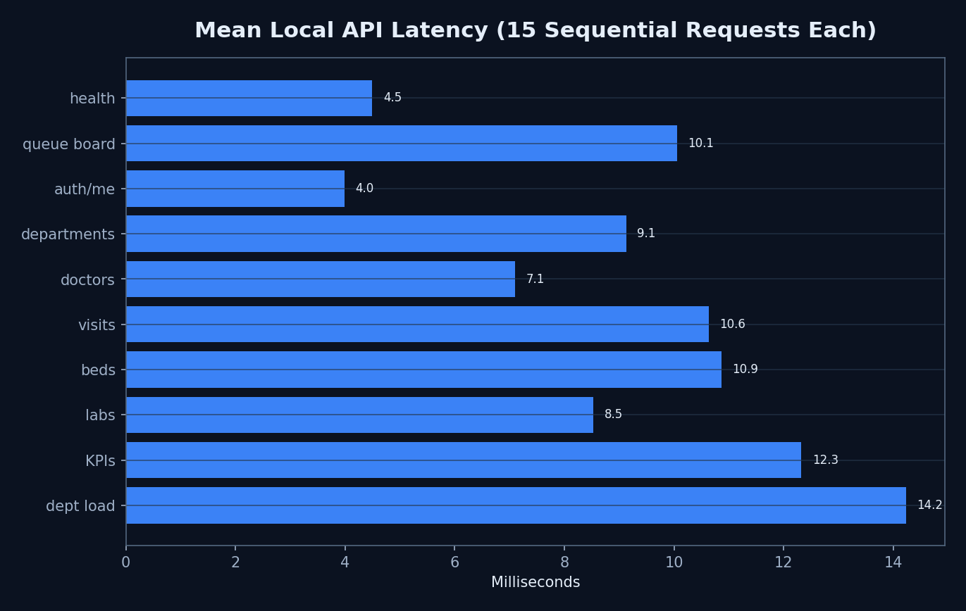
Figure 7.1 Local mean read latency.
JWT and role checks were exercised indirectly through successful role logins and protected data loads. No unauthorised access matrix, penetration test, dependency scan or privacy review was executed. The unauthenticated WebSocket is a known gap.
Latency values come from one sequential loopback client; no throughput, tail latency under load, memory saturation or multi-process behaviour was measured.

CHAPTER 7 SYSTEM TESTING

7.6 User Acceptance Limit
The screenshots show real application output with synthetic demonstration data, but no hospital staff or independent user group evaluated usefulness, clarity or workflow fit. Therefore user acceptance is unmeasured and is listed as future work.

CHAPTER 8 RESULTS AND OUTPUT SCREENS

8.1 Public Waiting Board
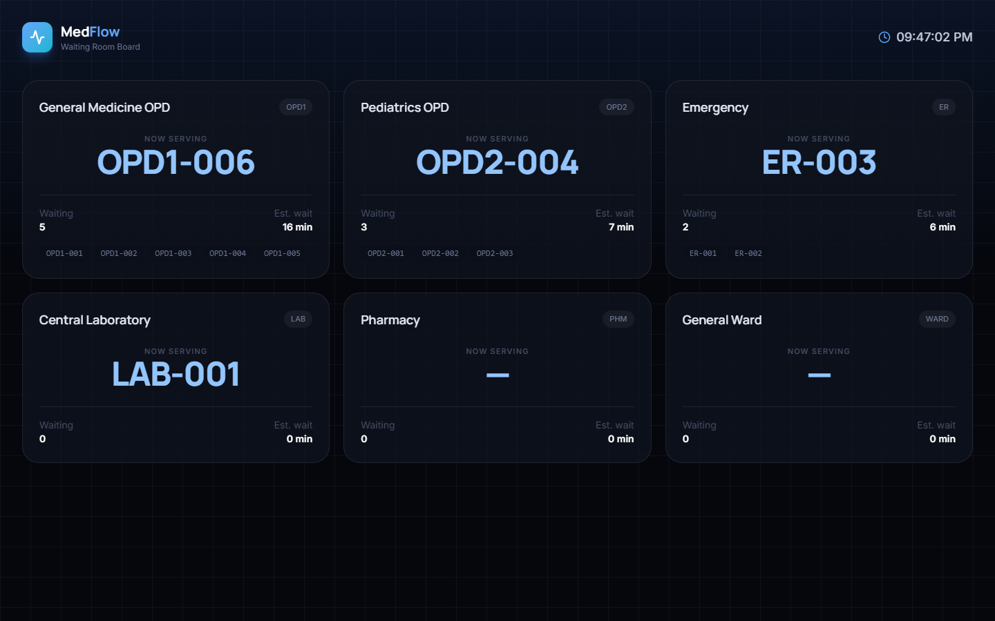
Figure 8.1 Public waiting board
Large token cards make current and upcoming queue state visible without authentication.

CHAPTER 8 RESULTS AND OUTPUT SCREENS

8.2 Administrator Overview
Figure 8.2 Administrator dashboard
The populated snapshot combines KPI, department and capacity evidence.

CHAPTER 8 RESULTS AND OUTPUT SCREENS

8.3 Reception Output
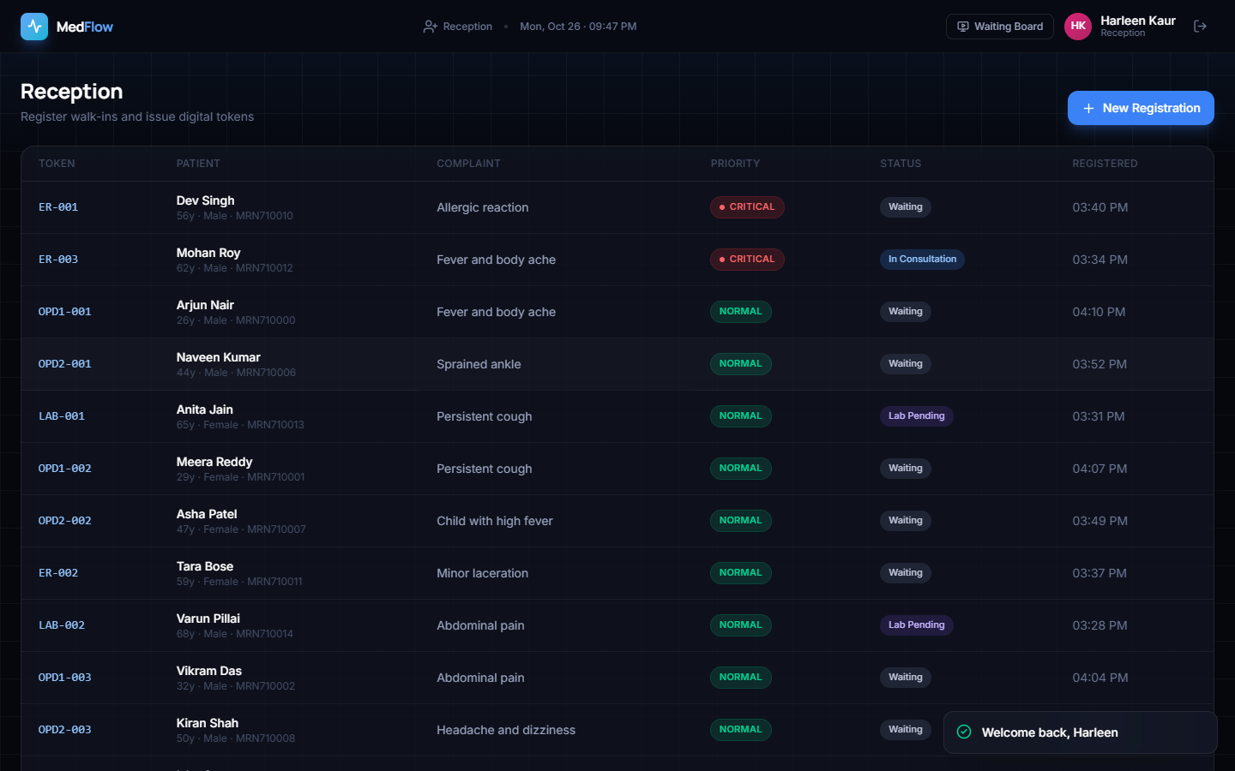
Figure 8.3 Reception dashboard
The registration list shows the operational identity of each visit.

CHAPTER 8 RESULTS AND OUTPUT SCREENS

8.4 Registration Input
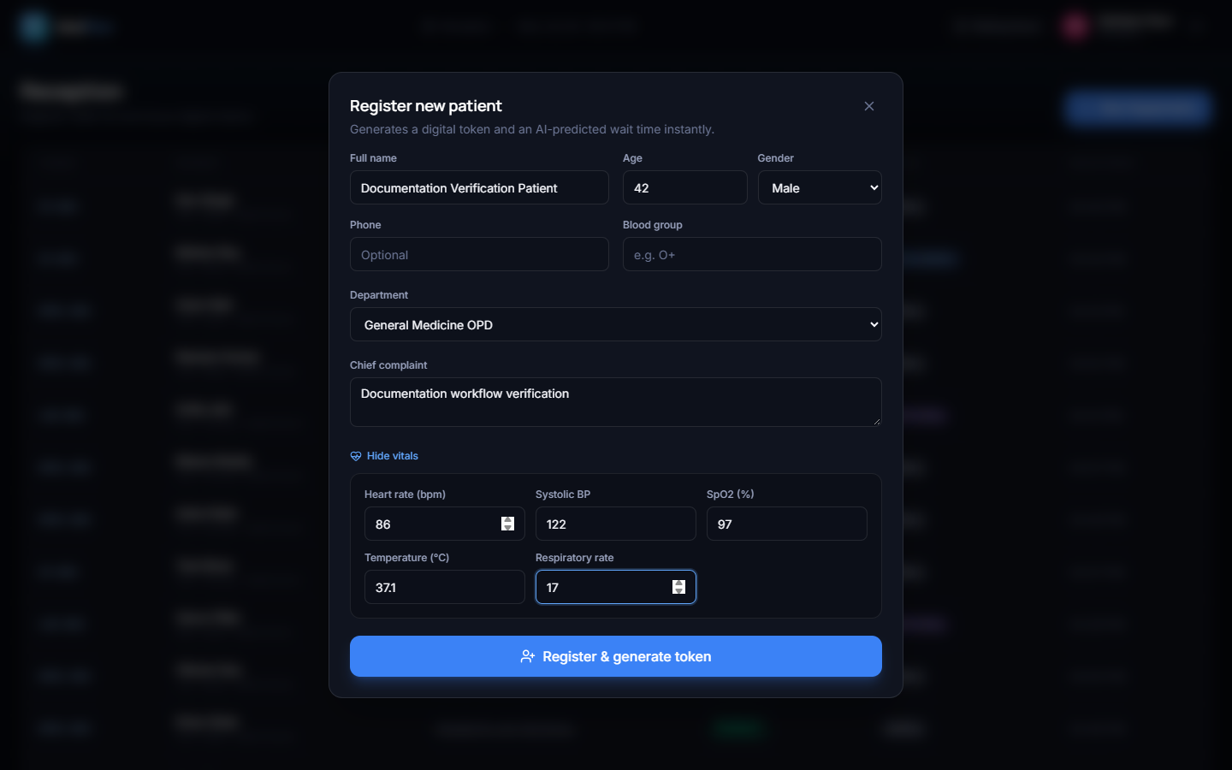
Figure 8.4 Registration form
Vitals are optional inputs to triage prediction.

CHAPTER 8 RESULTS AND OUTPUT SCREENS

8.5 Doctor Queue
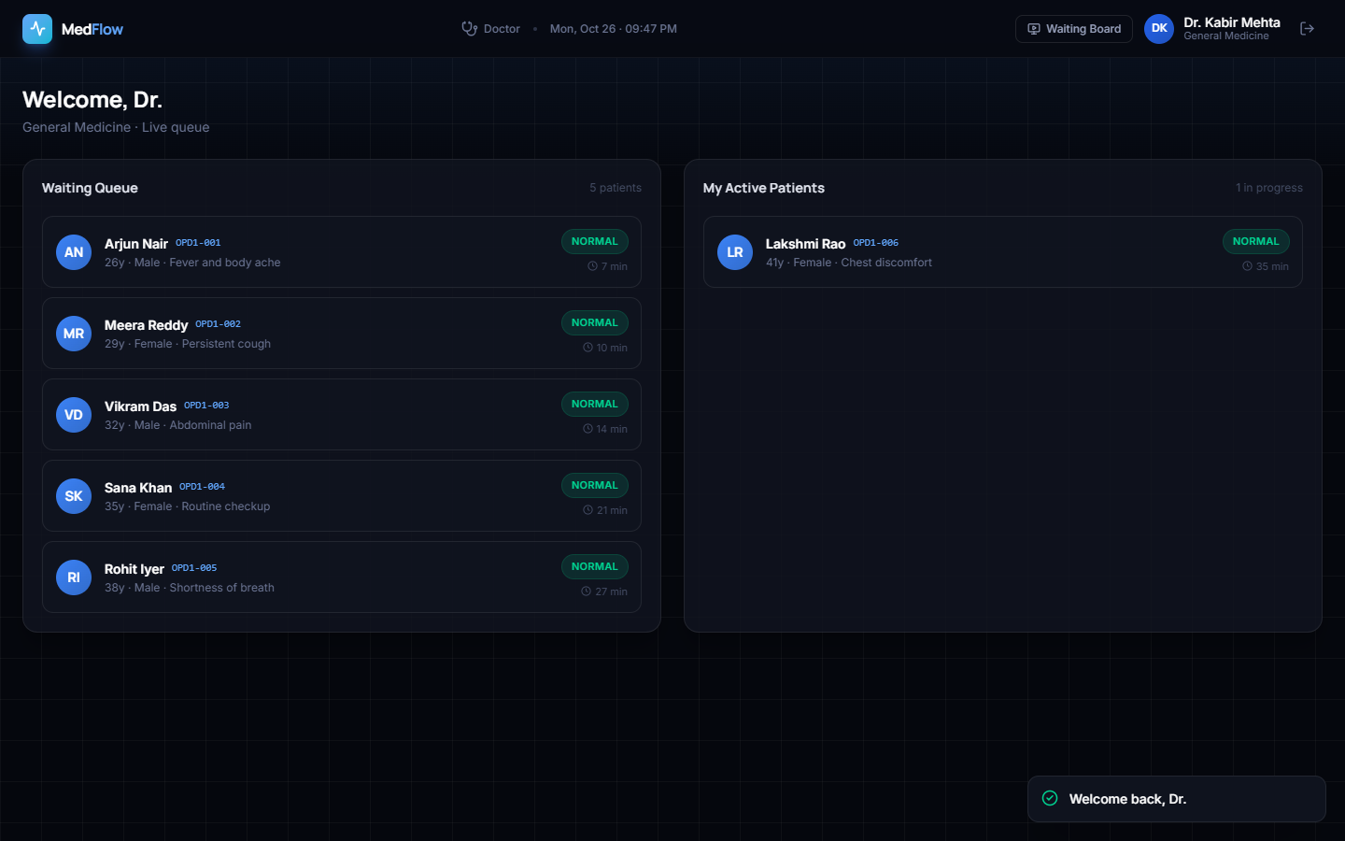
Figure 8.5 Doctor dashboard
Waiting and active visits are separated.

CHAPTER 8 RESULTS AND OUTPUT SCREENS

8.6 Patient Detail
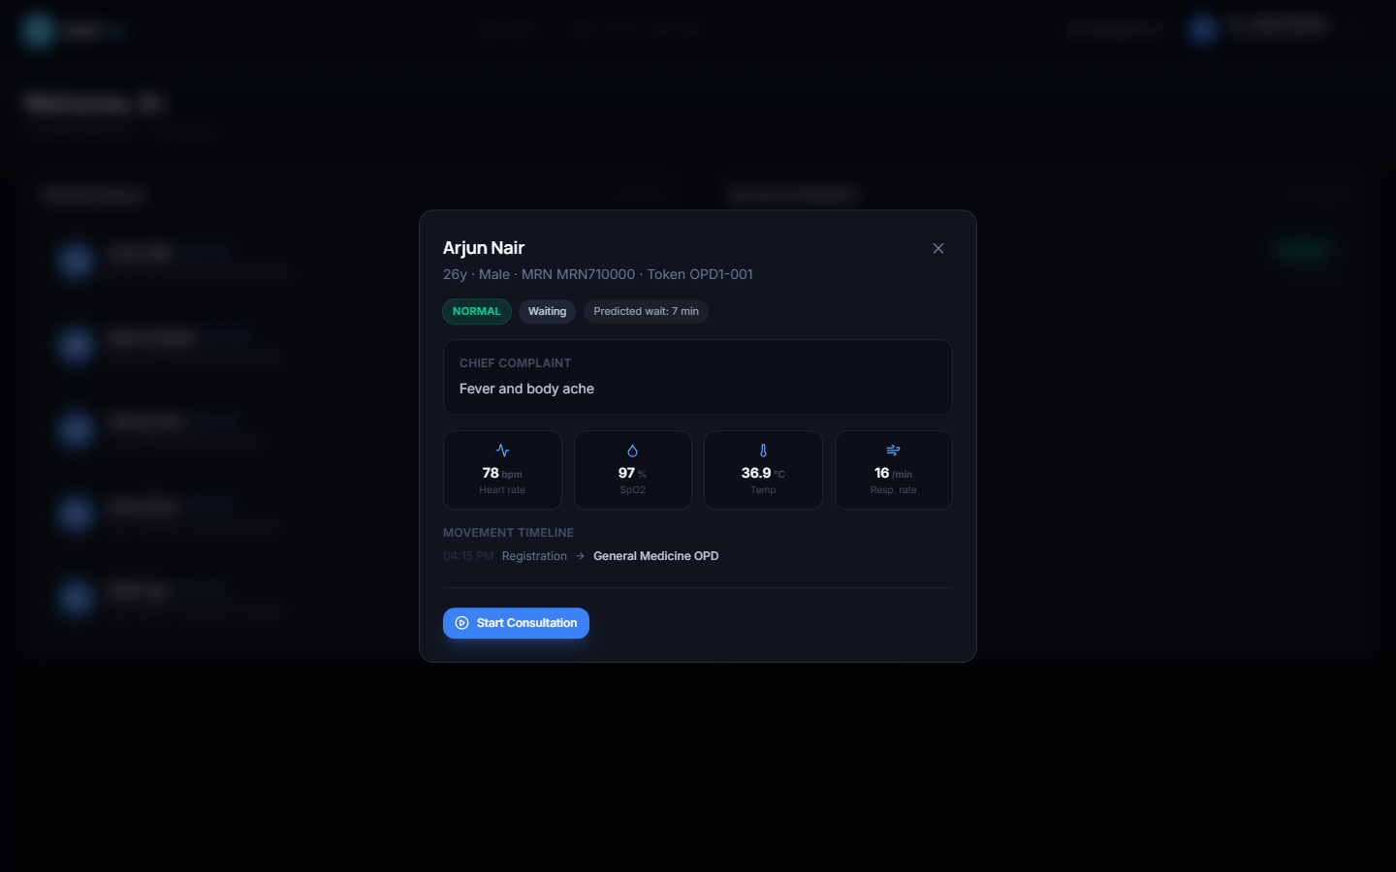
Figure 8.6 Patient detail
The modal shows complaint, vital context and movement.

CHAPTER 8 RESULTS AND OUTPUT SCREENS

8.7 Laboratory Order
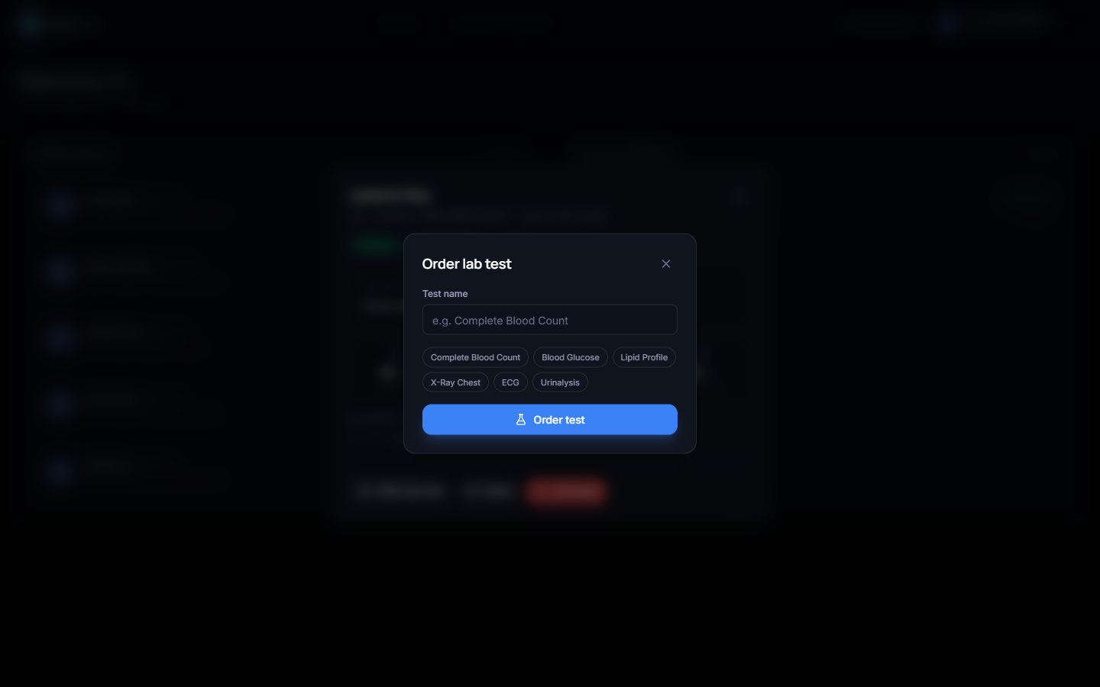
Figure 8.7 Laboratory order
A named test can be ordered from the consultation.

CHAPTER 8 RESULTS AND OUTPUT SCREENS

8.8 Admission Selection
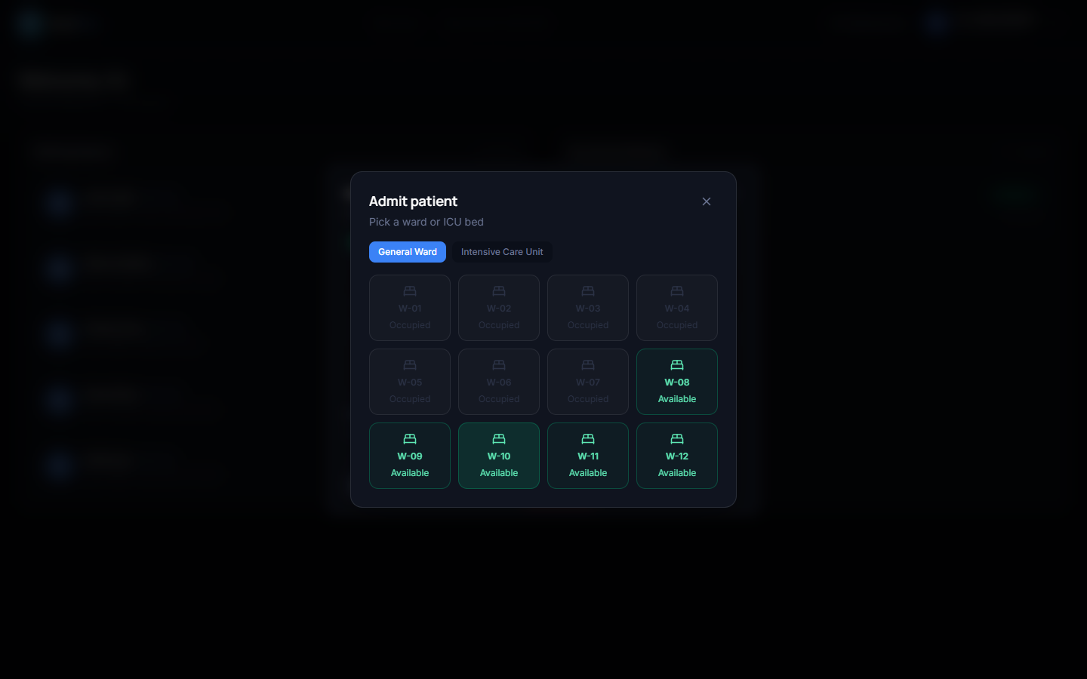
Figure 8.8 Admission modal
Availability is visible before selection.

CHAPTER 8 RESULTS AND OUTPUT SCREENS

8.9 Ward Capacity
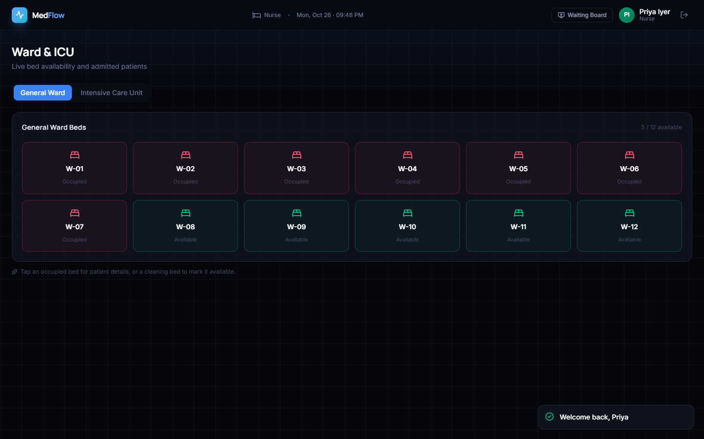
Figure 8.9 Ward bed board
Seven of twelve demonstration ward beds are occupied.

CHAPTER 8 RESULTS AND OUTPUT SCREENS

8.10 ICU Capacity
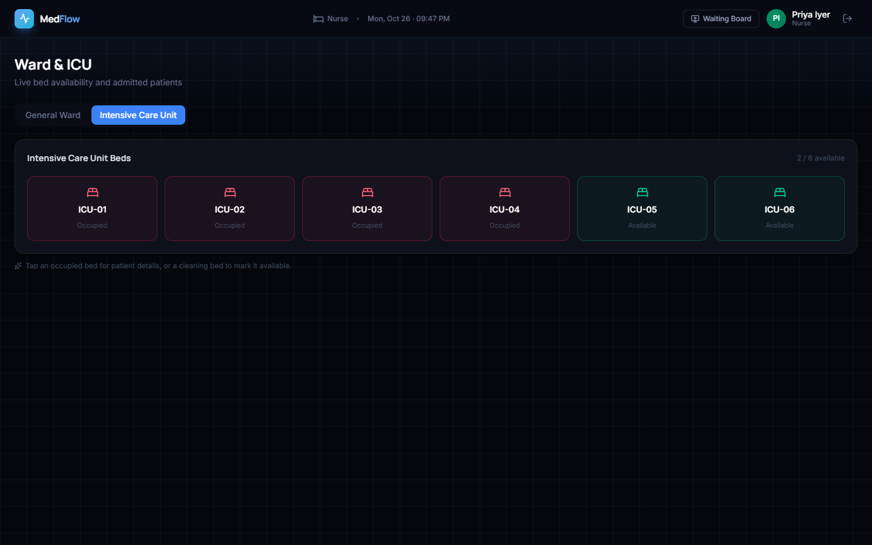
Figure 8.10 ICU bed board
Four of six demonstration ICU beds are occupied.

CHAPTER 8 RESULTS AND OUTPUT SCREENS

8.11 Laboratory Workflow
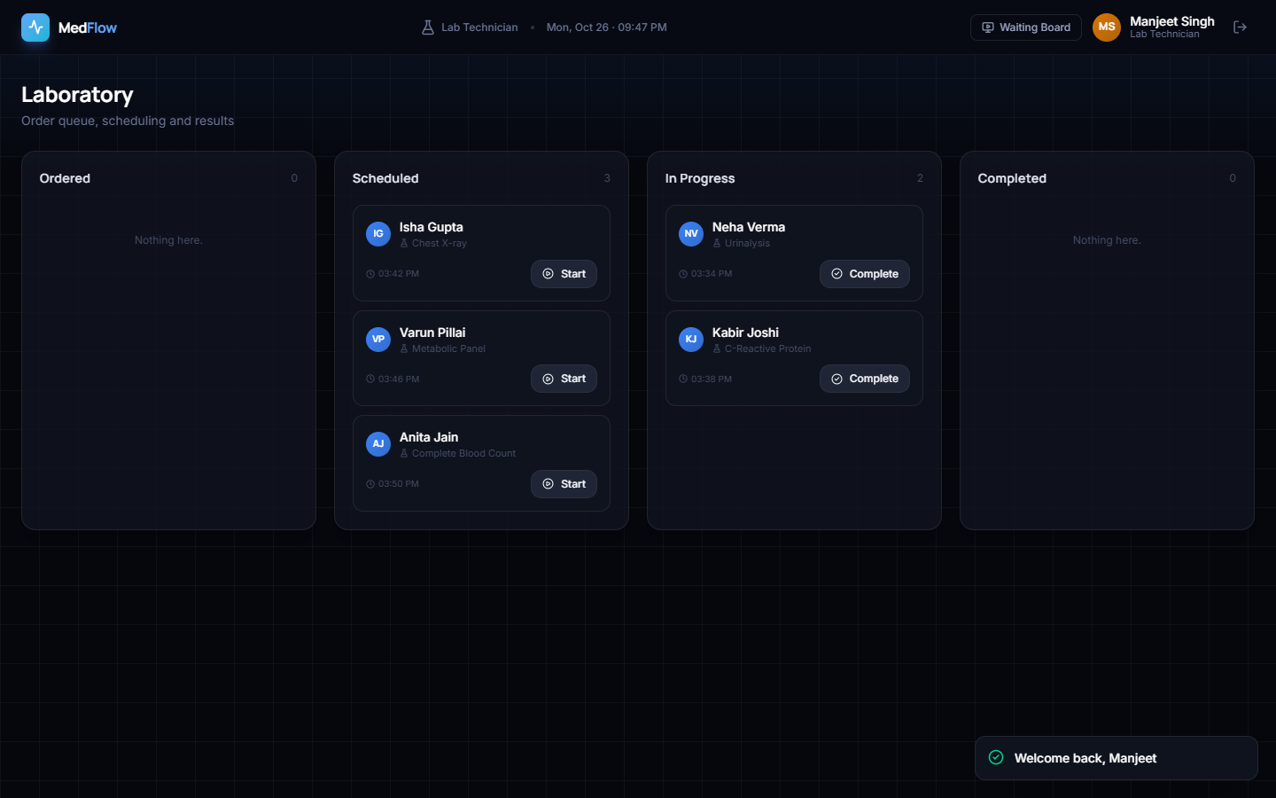
Figure 8.11 Laboratory dashboard
Five synthetic tests populate scheduled and in-progress work.

CHAPTER 8 RESULTS AND OUTPUT SCREENS

8.12 Model Results
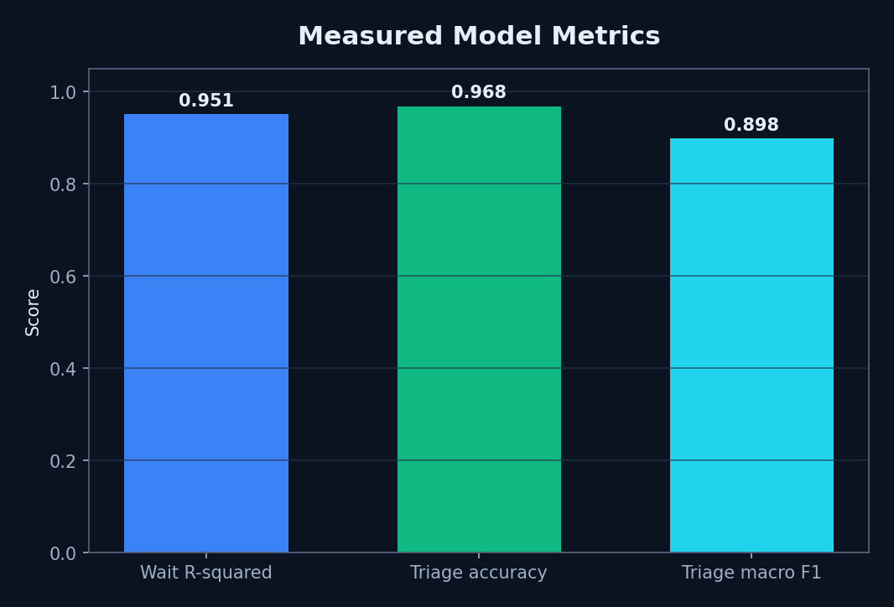
Figure 8.12 Model metrics
Scores summarise generator-matched test performance.

CHAPTER 8 RESULTS AND OUTPUT SCREENS

8.13 Confusion and Failure Analysis
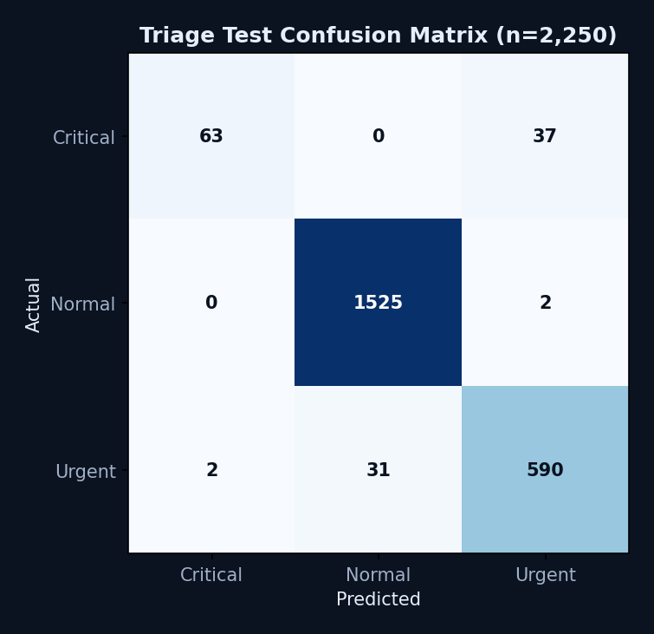
Figure 8.13 Triage confusion matrix
Critical recall of 63% is the main model failure finding.

CHAPTER 8 RESULTS AND OUTPUT SCREENS

8.14 API and Capacity Results
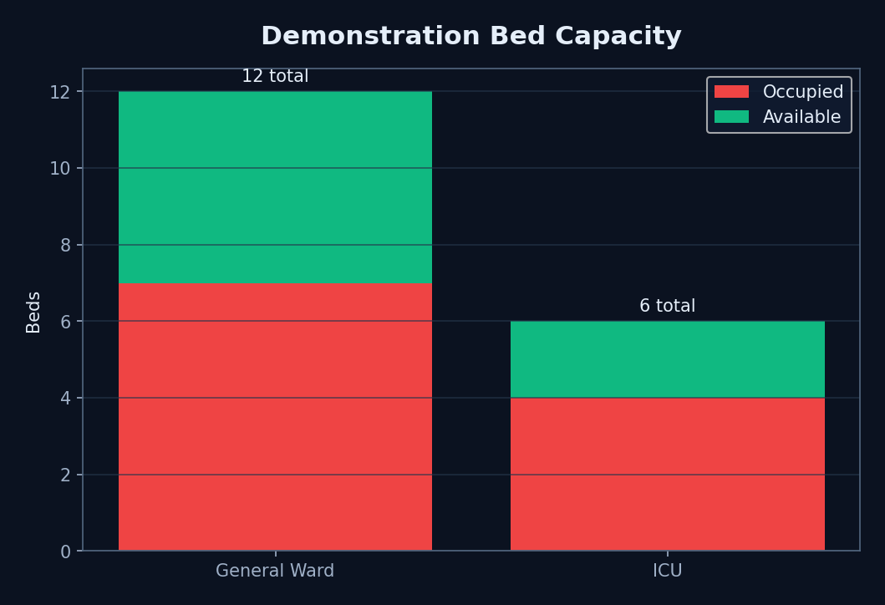
Figure 8.14 Demonstration bed capacity
Capacity is a synthetic application snapshot, not hospital utilisation evidence.

CHAPTER 8 RESULTS AND OUTPUT SCREENS

8.15 Objectives versus Outcomes
Table 8.1 Objectives versus outcomes.
Objective | Outcome
Tokens | Achieved
Movement | Partial
Lab workflow | Achieved; no optimisation evidence
Bed visibility | Achieved
AI assistance | Prototype achieved on synthetic data
Role dashboards | Achieved
Tokens, role dashboards, model integration, laboratory state and bed visibility were achieved as prototype functions. Movement tracking is partial, laboratory scheduling is not optimised and waiting-time reduction was not measured. The correct conclusion is functional integration with explicit gaps.

CHAPTER 9 CONCLUSION

9.1 Summary and Objectives Achieved
CareFlow implements one coherent patient-flow prototype across registration, queue, consultation, laboratory and bed state. The application executed successfully with populated data, all measured reads returned HTTP 200 and the frontend built successfully.
The model figures are reproducible but synthetic. The project’s valid contribution is an integrated operational design and measured prototype, not a clinical or deployment claim.

CHAPTER 9 CONCLUSION

9.2 Findings, Applications and Limitations
Priority-aware sorting, shared visit state and live role views are practical foundations for a future hospital operations tool. The same architecture could support outpatient centres, diagnostic facilities or teaching simulations.
Critical recall, absent real data, missing tests, local-only persistence, security gaps and incomplete transition coupling define the present boundary.

CHAPTER 10 FUTURE SCOPE

10.1 Improvements and Further Research
Next work should obtain governed, de-identified operational data; use temporal and external validation; optimise critical recall; calibrate prediction uncertainty; model service capacity explicitly; and conduct clinician-led usability and safety assessment.
Automated unit, integration and end-to-end tests should cover every role and state transition.

CHAPTER 10 FUTURE SCOPE

10.2 Scalability, Deployment and Integration
A production redesign should use PostgreSQL, a managed message broker, authenticated multi-instance live channels, TLS, secret management, audit trails, backups and observability. HL7 FHIR interfaces could connect registration, laboratory, admission and EHR systems.
Demand forecasting and staffing recommendations should be introduced only after prospective evaluation with real operational outcomes.

REFERENCES
[1] S. A. N. Saritha, G. Kalnoor, P. R. Bhat, P. A. Rao, P. Prajwal, and P. T. Pradeep, ‘Alleviate: An AI-Powered Mobile Application for Personalized Healthcare Management and Doctor Recommendation,’ IEEE Access, vol. 13, pp. 215822–215832, 2025, doi: 10.1109/ACCESS.2025.3647089.
[2] S.-K. Tan, S.-C. Chong, K.-K. Wee, and L.-Y. Chong, ‘Personalized healthcare: A comprehensive approach for symptom diagnosis and hospital recommendations using AI and location services,’ Journal of Informatics and Web Engineering, vol. 3, no. 1, pp. 117–135, 2024.
[3] M. Abinaya and R. Ganesan, ‘Effective search mechanism for finding nearest healthcare facilities,’ in Proc. Global Conference on Communication Technologies, 2015, pp. 534–538.
[4] M. W. Munir, S. M. Omair, and M. Z. U. Haque, ‘An Android based application for determine a specialized hospital nearest to patient’s location,’ International Journal of Computer Applications, vol. 118, no. 9, pp. 43–46, 2015.
[5] R. A. Nimbalkar and R. A. Fadnavis, ‘Domain specific search of nearest hospital and healthcare management system,’ in Proc. Recent Advances in Engineering and Computational Sciences, 2014, pp. 1–5.
[6] A. Kumar, ‘Disease prediction and doctor recommendation system using machine learning approaches,’ International Journal for Research in Applied Science and Engineering Technology, vol. 9, no. 7, pp. 34–44, 2021.
[7] L. Bjorkdahl, O. Pauli, J. Ostman, C. Ceccobello, S. Lundell, and M. Kjellberg, ‘Towards holistic disease risk prediction using small language models,’ arXiv:2408.06943, 2024.

REFERENCES
[8] R. Umbare, R. Patil, T. Mukund, A. Rathod, and P. Rajurkar, ‘A smart healthcare application using artificial intelligence and machine learning,’ in Proc. ICIPCN, 2024, pp. 204–210.
[9] D. Gujar, R. Biyani, T. Bramhane, S. Bhosale, and T. P. Vaidya, ‘Disease prediction and doctor recommendation system,’ International Research Journal of Engineering and Technology, vol. 5, pp. 3207–3209, 2018.
[10] D. Mogaveera, V. Mathur, and S. Waghela, ‘E-health monitoring system with diet and fitness recommendation using machine learning,’ in Proc. ICICT, 2021, pp. 694–700.
[11] P. Tanwar, K. Bansal, A. Sharma, and N. Dagar, ‘AI based chatbot for healthcare using machine learning,’ in Proc. ICAICCIT, 2023, pp. 751–755.
[12] R. Surve, T. Purohit, R. Joseph, and P. Shaikh, ‘Healthcare chatbot using machine learning and NLP,’ in Proc. ICAST, 2023, pp. 411–416.
[13] H. Mendapara, S. Digole, M. Thakur, and A. Dange, ‘AI based healthcare chatbot system using natural language processing,’ International Journal of Scientific Research and Engineering Development, vol. 4, no. 2, pp. 89–96, 2021.
[14] M. M. Rahman et al., ‘Web-based multiple disease prediction system with transfer learning and healthcare chatbot,’ in Proc. IEEE ICMI, 2024, pp. 1–5.

REFERENCES
[15] J. Tseng et al., ‘An interactive healthcare system with personalized diet and exercise guideline recommendation,’ in Proc. TAAI, 2015, pp. 525–532.
[16] T. Bhanuteja, K. V. N. Kumar, K. S. Poornachand, C. C. V. N. Ashish, and P. Anudeep, ‘Symptoms based multiple disease prediction model using machine learning approach,’ IJITEE, vol. 10, no. 9, pp. 67–72, 2021.
[17] ‘Waiting Time Prediction in Queue Management: Leveraging Machine Learning Approach,’ in Proc. International Conference on Recent Progresses in Science, Engineering and Technology, 2024.
[18] ‘Prediction of outpatient waiting time using machine learning in a tertiary children’s hospital,’ Translational Pediatrics, 2023.
[19] ‘Dissatisfaction-considered waiting time prediction for outpatients with interpretable machine learning,’ Health Care Management Science, 2024.

APPENDIX A: IMPORTANT CODE

A.1 Queue ordering
The excerpt below is condensed from the checked-in implementation; ellipses indicate omitted arguments rather than new logic.
PRIORITY_RANK = {critical: 0, urgent: 1, normal: 2}
def sort_key(visit):
return (PRIORITY_RANK.get(visit.priority, 3), visit.token_number)

APPENDIX A: IMPORTANT CODE

A.2 Wait prediction features
The excerpt below is condensed from the checked-in implementation; ellipses indicate omitted arguments rather than new logic.
X = DataFrame([{
"department_type": dept_code, "queue_ahead": queue_ahead,
"hour": hour, "priority": priority_code,
"avg_service_minutes": avg_service_minutes, "servers": servers
}])
prediction = model.predict(X)[0]

APPENDIX A: IMPORTANT CODE

A.3 Visit creation orchestration
The excerpt below is condensed from the checked-in implementation; ellipses indicate omitted arguments rather than new logic.
priority_label, confidence = predict_triage(...)
ahead = queue_ahead_count(db, department.id, priority)
predicted_wait = predict_wait_minutes(...)
db.add(visit); db.add(MovementLog(...)); db.commit()
await manager.broadcast("visit_created", visit_out.model_dump())

APPENDIX A: IMPORTANT CODE

A.4 Role enforcement
The excerpt below is condensed from the checked-in implementation; ellipses indicate omitted arguments rather than new logic.
def require_roles(*roles):
def checker(user = Depends(get_current_user)):
if user.role not in roles:
raise HTTPException(status_code=403)
return user
return checker

APPENDIX B: INSTALLATION AND USER GUIDE

B.1 Local Installation
Backend: enter 8.ProjectCode/backend, activate the supplied virtual environment or create one, install requirements.txt and ensure medflow.db contains the desired data. Frontend: enter 8.ProjectCode/frontend and run npm install if dependencies are absent.
The project stores models under backend/app/ml/artifacts. Running `python -m app.ml.train` regenerates them and changes the artefact files; do so only when intentional.

APPENDIX B: INSTALLATION AND USER GUIDE

B.2 Start and Sign In
Start the backend with `python -m uvicorn app.main:app --port 8010`. Start the frontend with `npm run dev`; open http://127.0.0.1:5173. Use the demo role account shown on the login screen. The public waiting board is /board.
The code contains no run.bat. Stop both development servers with Ctrl+C.

APPENDIX B: INSTALLATION AND USER GUIDE

B.3 Role Workflows
Reception creates a registration; doctors open a queue card and start consultation; doctors may order a test or choose an available bed; laboratory staff advance test work; nurses select a ward or ICU tab to inspect beds; administrators monitor KPIs.
Use only synthetic demonstration information unless appropriate privacy, consent and institutional controls are established.

APPENDIX C: ADDITIONAL SCREENS

C.1 Staff Sign-In
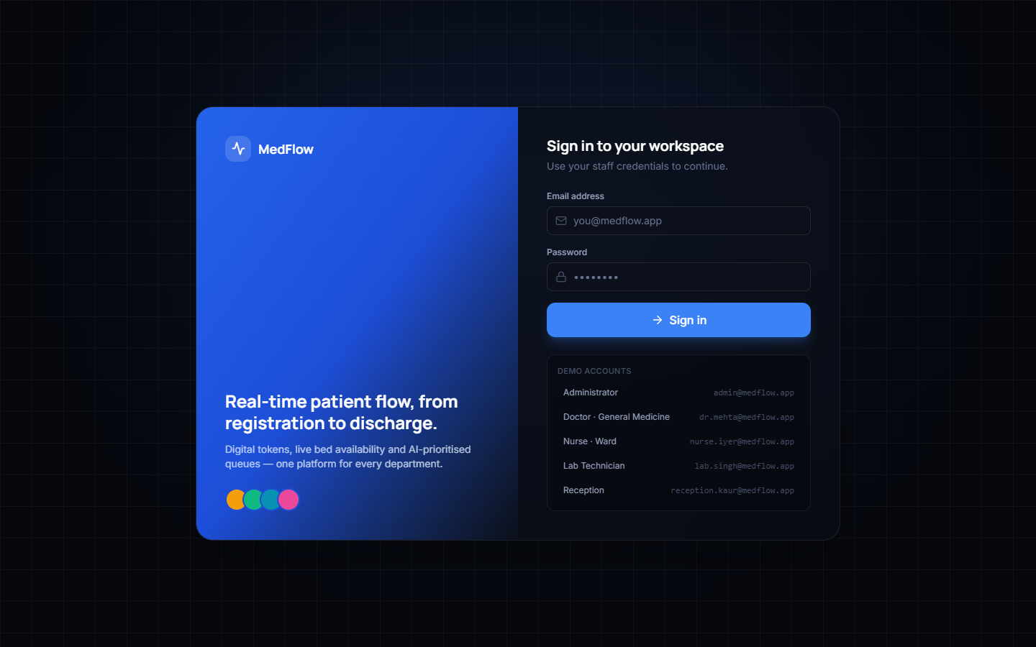
Figure C.1 Staff sign-in screen.
This is an actual capture of the running prototype using synthetic demonstration data.

APPENDIX C: ADDITIONAL SCREENS

C.2 Registration Detail
Figure C.2 Populated registration form.
This is an actual capture of the running prototype using synthetic demonstration data.

APPENDIX C: ADDITIONAL SCREENS

C.3 Patient Detail
Figure C.3 Patient detail and movement.
This is an actual capture of the running prototype using synthetic demonstration data.

APPENDIX C: ADDITIONAL SCREENS

C.4 Admission Detail
Figure C.4 Available-bed selection.
This is an actual capture of the running prototype using synthetic demonstration data.

